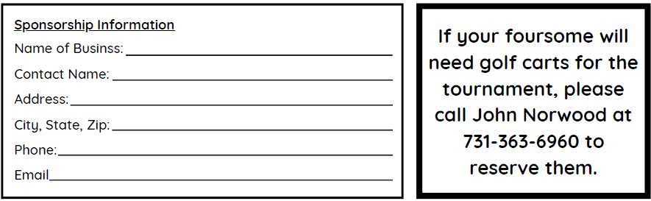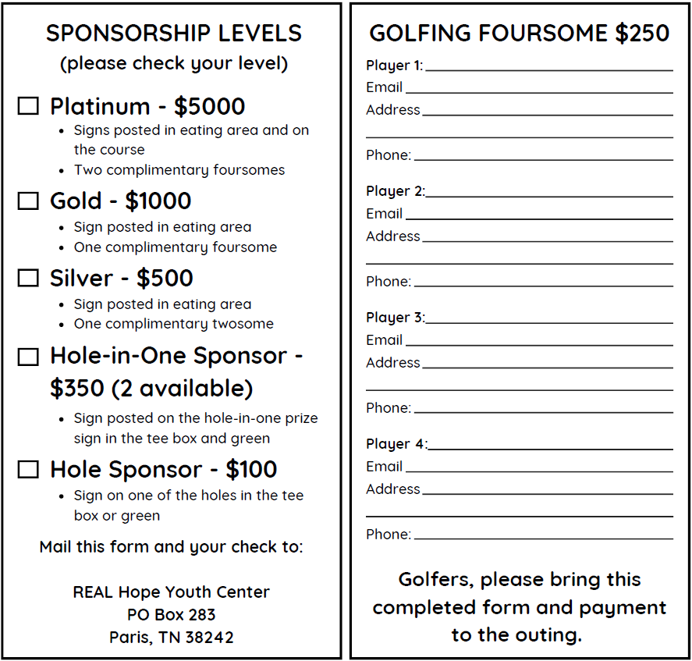

**$25000**

Includes – Real Hope Facebook ad & sign posted on course during event.

Includes – Real Hope Facebook Page ad & sign posted on hole during event.

Includes – Real Hope Facebook Page ad & banner at event site.

Includes – Real Hope Facebook ad & banner at event site.

Includes – Real Hope Facebook Page ad, banner at event site, and 1 complimentary foursome.

**$300**

**If your foursome will need golf carts for the tournament, please contact**

**Carl Anderson at 731-227-4689 to reserve them.**

**Please contact Carl Anderson with your team entry & if you will need a cart(s).**

**Email completed forms to** [**cranderson7@yahoo.com**](mailto:cranderson7@yahoo.com)**, or bring to tournament.**

**Carl Anderson**

**731-227-4689**

**\*300 per Team**

Friday, Sept. 26, 2025

**doowron21@gmail.com**

**15th Annual**

